Communication System Design

Document History

Date | Author | Description
2024-01-20 | Vincent Lao | Initial Draft

Introduction

This is the design document of a robotic charging network. This robotic charging network supports the following:

- Multiple independent robot
- Multiple charging station
- Automatic identification and searching
- Charging station path location broadcast to allow robot to find the know where to go
- Automatic disconnection detection via heartbeat implementation
- Basic packet protection by implementing robot/charging station exclusive communication while charging is in progress

Operation Description

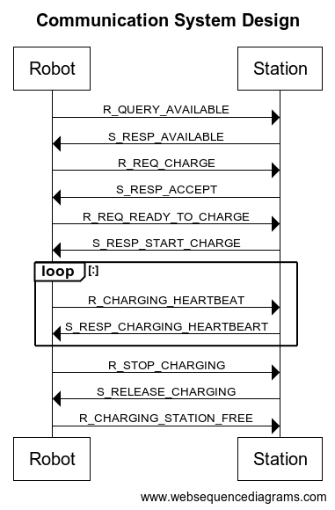

Description

- When searching for an available charging station, a robot will broadcast a message R_QUERY_AVAILABLE with the type of charging required. with a receiver ID of zero (broadcast to all stations within range).

- Stations that are free and supports the capacity can respond with S_RESP_AVAILABLE, indicating its’ position in the packet.

- Robot will then send R_REQ_CHARGE with RAND code

- Available station will ACK the request (S_RESP_ACCEPT) with RAND code.

Succeeding exchanges will start using the Hash(RAND code + counter) in the packet header.

- Once the robot moves into position, it will send R_REQ_READY_TO_CHARGE

- Station will check the presence of the robot with a sensor. Confirmed, it will inform that it is starting to send charging current (S_RESP_START_CHARGE).

- The Robot will periodically send a heartbeat containing the charge percentage

- The charging station will also send a heartbeat. It will also trickle down current as the charge percentage increases to near full.

- Once done (battery became 100%), it will send a request to stop charging. The robot BMS will also automatically start trickle charging to prevent damage.

- Charging station will stop the charging process and send a response S_RELEASE_CHARGING.

- The robot will move out of the charging position so that others can use the charging slot.

- Once out, the robot will inform the charging station that it has moved out of the station. The station will then be ready for next charge request.

Notes:
- ID of robot and charger are included in the packet except the broadcast packet where the ID will be 0.
- There is a retry counter if no response is received within a specified time for packets that requires a response. For packets that does not require a response, it will be ignored.
- Sequence number for each packet is also available to monitor any packet loss
- In the case of error packet reception, either side will have the logic to automatically handle the situation depending on the error.
- Received packets that are unexpected are ignored (eh receiver ID not matched). For broadcast packet received, if Msg Type is not what is expected, it will be ignored.

Packet format

Name | Length (in bytes) | Content | Description
Preamble | 2 | 0xA5, 0x81 | Packet indicator (Can be different for a robot and a charging station)
Source ID | 4 | nnnnnnnn | Unique vehicle ID or charging station ID
Receiver ID | 4 | nnnnnnnn | Unique vehicle/charging station ID: 0 – broadcast to everyone
Sequence counter | 2 | Number | Counter for number of messages exchanged
Retry counter | 2 | Number | Counter for the number of retries
Last error | 1 | number | Error code
Exchange code | 4 | numbers | Simple security code. Last 4 digit of HASH(RAND code of receiver + increment counter). This security mechanism only protects the succeeding communications. It does not protect against a third-party from eavesdropping the start of the handshake and intruding. Before the handshake, this code is ignored.
Data packet length in bytes | 2 | number | Size of data packet in number of bytes
Data packet | variable |  | Data packet (see Data Packet Format)
CRC | 2 |  | Checksum

Data Packet Format

Message type: R_QUERY_AVAILABLE

Name | Length | Content | Description
Message Type | 1 | 0x01 | Query if any of the nearby chargers are free and the charging current and capacity is supported.
Robot type | 2 | nn | Robot type
Charging current | 2 | nn | Current in mA

Message type: S_RESP_AVAILABLE
Name | Length | Content | Description
Message Type | 1 | 0x81 | Respond to query
Data | 1 | 0x01 or 0x00 | Respond with availability: 1 is free, 0 – unavailable
Location | 16 | Position and location info | Charging location, position, orientation, etc.

Message type: R_REQ_CHARGE
Name | Length | Content | Description
Message Type | 1 | 0x02 | Request to use charging station
RAND code | 16 | code | Exchange code that will be used for succeeding exchange.

Message type: S_RESP_ACCEPT
Name | Length | Content | Description
Message Type | 1 | 0x82 | Accept
RAND code | 16 | code | Exchange code that will be used for succeeding exchange.

Message type: R_REQ_READY_TO_CHARGE
Name | Length | Content | Description
Message Type | 1 | 0x03 | Request vehicle is in position and ready to start charging
Max charging current | 1 | nn | Specify charging current

Message type: S_RESP_START_CHARGE
Name | Length | Content | Description
Message Type | 1 | 0x83 | Charging station can start pumping current

Message type: R_CHARGING_HEARTBEAT
Name | Length | Content | Description
Message Type | 1 | 0x04 | Charging heartbeat, also specify the percentage from BMS
Charging state/percentage | 1 | 0-100% | Charge percentage full

Message type: S_RESP_CHARGING_HEARTBEART
Name | Length | Content | Description
Message Type | 1 | 0x84 | Charging station can start pumping current

Message type: R_CHARGE_FULL/R_STOP_CHARGING
Name | Length | Content | Description
Message Type | 1 | 0x05 | Request to stop chargingBMS report charge is full

Message type: S_RELEASE_CHARGING
Name | Length | Content | Description
Message Type | 1 | 0x85 | Charger has stopped the charging

Message type: R_CHARGING_STATION_FREE
Name | Length | Content | Description
Message Type | 1 | 0x06 | Inform charging station that they can accept another robot. This tells the charging station whether they can start accepting another request or not.

Message type: R_ERROR
Name | Length | Content | Description
Message Type | 1 | 0x7F | Error from robot side
Error code | 1 | nn

Message type: S_ERROR
Name | Length | Content | Description
Message Type | 1 | 0xFF | Error from charging station side
Error code | 1 | nn

Data struct

typedef struct {
uint16_t u16_preamble;
uint32_t u32_source_id;
uint32_t u32_receiver_id;
uint16_t u16_sequence_counter;
uint16_t u16_retry_counter;
uint16_t u16_last_error;
uint8_t u8a_exchange_code[4];
uint16_t u16_data_packet_length;
uint8_t data[];
} ROBO_CHARGING_SYSTEM_PACKET;

uint16_t u16_crc;

END OF DOCUMENT

